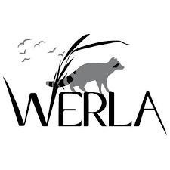 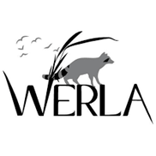

**Wildlife Education and Rehabilitation of Louisiana**

|  |  |  |
| --- | --- | --- |
|  | **Supplies** |  |
| » Wild Bird Seed  » Black Oil Sunflower Seeds  » Cracked Corn  » Whole Dry Corn  » Raw Unsalted Nuts  » Unsweetened Applesauce  » Dark Molasses  » Boxed Baby Cereal  » Gerber First Foods Baby Food  » Purina Cat Chow  » Purina Kitten Chow | » Fresh Fruits and Vegetables: apples, grapes, bananas, melon, sweet potatoes, greens, carrots, pears, squash, zucchini  » Raw, fresh or frozen meats: chicken, venison, turkey, fish, red meat, liver, gizzards  » Timothy Hay  » Paper Towels  » Dawn Dish Detergent  » Pinesol | » Bleach  » Laundry Detergent  » Hand Soap  » Exam Gloves, sizes Med and Large  » Toilet Paper  » Clorox Wipes  » Baby Wipes (preferably unscented)  » Sevens Dust |
|  | **Other Items Needed** |  |
| » Leather Welding Gloves  18 in and 23 in  » Feeding Bowls- 4 Qt, 8 Qt, 6 in, 8 in, 10 in | » Pet Crates, all sizes, plastic, not wire  » Bird/ Pet Cages  » Aquariums, all sizes | » Copy Paper  » Sticky Notes  » External Hard Drive  » Laptop- 300+ GB memory |
|  | **Gently Used Items** |  |
| » Newspapers- folded with no glossy inserts | » Fleece Blankets  » Towels  » Tshirts | » Pillow Cases  » Sheets |
|  | **Monetary Donations** |  |
| Monetary Donations can be mailed to  WERLA  PO Box 7462  Shreveport, LA 71137 | Donate on PayPal  Werlainc@gmail.com     | Donate on FaceBook  Wildlife Education and Rehabilitation of Louisiana     |
| Donate with Venmo  @WERLA-WildlifeEdandRehabofLa  How to Accept Venmo in WordPress - Qode ...   |  | Amazon Wish List  WERLA    https://www.amazon.com/hz/wishlist/ls/1JT02KIVK9MB1?ref_=wl_share |